***Serial Subscription Tracking System***

Project Documentation Submitted to the Faculty of the

School of Computing and Information Technologies

Asia Pacific College

In Partial Fulfillment of the Requirements for

System Analysis and Detailed Design

MSYADD1

Submitted by:

**Puyot, Fracie Princes (Team Leader)**

**Alingan, Mohasien (Member)**

**Bah, Mamadou (Member)**

**Bueno, Jerwin James (Member)**

**Delgado, Ren Henry (Member)**

Submitted to:

**Mr. Jose Eugenio L. Quesada**

Course Instructor

October 2025

1st Term

A.Y. 2025-2026

## PM DOCS CHAPTER 2

#### Charter

# **Purpose**

The Department of Science and Technology - Science and Technology Information Institute (DOST-STII) Library currently manages its numerous serial publication subscriptions (journals, magazines, bulletins) through a manual, inefficient process. This leads to inconsistent monitoring of deliveries, ineffective communication with suppliers, time-consuming manual reporting, and a lack of financial visibility.

This project aims to develop a Serial Subscription Tracking System, a web-based platform that will automate the end-to-end workflow. The system will provide real-time tracking, automated notifications, streamlined communication, and accurate financial reporting. This directly supports DOST-STII's mission to foster innovation and research in the Philippines by ensuring timely access to critical information resources, improving operational efficiency, and enhancing supplier accountability.

# **High-level project description**

The Serial Subscription Tracking System is a web-based application that will serve as a centralized platform for managing serial subscriptions. Key functionalities include:

It includes functions such as:

* Role-Based Dashboards: Tailored interfaces for Technical Processing Unit (TPU), Suppliers, General Services and Property Section (GSPS), Inspection Team, and Admin/IT.
* Real-Time Tracking: Monitor the delivery status of all serial publications.
* Automated Notifications & Alerts: Send reminders for expected delivery dates, alerts for delayed or undelivered issues, and updates to all relevant stakeholders.
* Integrated Communication Module: A built-in chat feature for direct communication between TPU, GSPS, and Suppliers.
* Automated Reporting: Generate quarterly and on-demand reports on delivery performance, undelivered items, subscription costs, and supplier compliance.
* Financial Visibility: Automatically track and deduct costs for confirmed deliveries, providing clear cost summaries.

# **High-level milestone schedule**

|  |  |
| --- | --- |
| **Milestone** | **Estimated Week** |
| Finalization of UI/UX wireframes and user flow for tracking, notifications, and reporting | Week 6 |
| Development of core features (serial issue tracking, supplier notifications, cost calculation) begins | Week 7 |
| Implementation of automated alerts & delivery status tracking module | Week 8 |
| Admin dashboard setup, role-based access control, and system integration | Week 9 |
| First internal testing (development team only) | Week 10 |
| Usability testing with TPU and Admin/IT staff | Week 11 |
| Gathering feedback from DOST-STII and making revisions | Week 12 |
| Final testing, polishing, and report generation validation | Week 13 |
| Project presentation and documentation finalization | Week 14 |

# **Rough cost estimate and budget**

This project is not expected to incur any direct monetary costs. Development will utilize free and open-source technologies (potential use of PHP/Python, MySQL/PostgreSQL, React/Vue.js). Essential resources, including operational data and domain expertise, will be provided by DOST-STII stakeholders.

# **Stakeholders**

* Technical Processing Unit (TPU) - Primary User. Responsible for tracking, monitoring, reporting, and communicating with suppliers.
* DOST-STII GSPS - Key User. Oversees procurement, delivery status, and validates supplier performance and compliance.
* Suppliers/Vendors - Key User. Receive notifications, update delivery status, and communicate directly with DOST-STII.
* Inspection Team - User. Verifies physical condition of deliveries and updates status within the system.
* Admin/IT (DOST-STII) - User/Maintainer. Manages user accounts, permissions, and system oversight.
* DOST-STII Management - Sponsor/Overseer - Interested in budgetary control, operational efficiency, and supplier accountability.

# **Project manager**

Fracie Prince Puyot, Group Leader

# **Project manager’s responsibilities**

* Assign tasks to team members and track their progress.
* Coordinate meetings between the team, adviser, and stakeholders.
* Review all work for quality assurance before client sharing.
* Manage stakeholder feedback and ensure its implementation.
* Organize the final project presentation and defense.
* Act as the primary point of contact for the project.

# **Project manager’s authority**

* Decide task priorities and the order of execution.
* Reassign tasks to ensure timely project completion.
* Resolve conflicts within the project team.
* Determine meeting schedules and set agendas.
* Approve the final version of all deliverables before submission.
* Make final decisions on project execution with team input.
* Represent the team in all discussions with the client and stakeholders

#### Objectives

The DOST-STII Library relies heavily on timely access to serial publications to support scientific research and innovation. Currently, the manual process used to monitor subscriptions results in delays, miscommunication with suppliers, and inefficient reporting. The key objective of this project is to automate the tracking and reporting of serial publications to significantly improve operational efficiency.

The outcome is expected to enhance communication, minimize manual intervention, ensure accuracy of reports, and support the broader goals of accountability, transparency, and efficient access to science and technology information.

**Categorized Objectives**

|  |  |  |
| --- | --- | --- |
| **Objective** | **Category** | **Measure** |
| Reduce delays in identifying and tracking undelivered serials | Operational Efficiency | 50% reduction in delivery delay response time |
| Improve communication with suppliers and stakeholders | Communication | 87.5% reduction in average supplier response time |
| Automate reporting processes to reduce manual workload | Reporting | 50% reduction in report generation time |
| Increase financial visibility of undelivered and delayed serial issues | Financial Management | 75% improvement in financial transparency and reporting |
| Improve stakeholder accountability and compliance through system alerts | Compliance and Monitoring | Real-time alerts sent for 100% of delivery issues |
| Ensure system compatibility with library’s IT infrastructure | Technical | Fully functional across all web browsers and devices used |
| Complete the system within allocated budget and timeframe | Budget & Timeline | 100% delivery within budget and set timeline |
| Create a centralized system for tracking all serial publications procured by DOST-STII. | Scope | Track all serial publications |
| Ensure the system is accessible only to authorized personnel and registered suppliers. | Security/Limitation | Restrict access to authorized users only |
| Provide tailored dashboards and notifications for key stakeholders (TPU, GSPS, Inspection Team, Suppliers). | Functional | Ensure all stakeholders have role-based access |

#### Scope

#### Within scope:

* Implementation of a role-based dashboard for Technical Processing Unit, GSPS, Inspection Team, and Suppliers.
* Automated notifications and reminders for upcoming, delayed, and undelivered serial issue deliveries.
* Real-time delivery status tracking and automated cost deduction upon confirmed delivery.
* Reporting module that generates Excel-compatible reports on delivery performance, undelivered items, supplier performance summaries, and cost breakdowns.
* User management functions including account creation, approval workflows, and role assignments for DOST-STII staff and registered suppliers

#### Out of scope:

* Public-facing access or interfaces for non-authorized users.
* Offline or local desktop functionality; the system will be entirely web-based and require internet connectivity.
* Handling of payment processing or procurement transactions beyond reporting supplier costs

#### Project Deliverables

• Functional Serial Subscription Tracking System deployed to a test and production environment.

• Requirements specification document outlining all use cases, data fields, and workflow rules.

• System architecture and design documentation, including data model diagrams and UI wireframes.

• Test plans and test case matrices covering unit, integration, and user acceptance testing.

• User manual and quick-start guides for each stakeholder role.

• Training materials and session delivery for DOST-STII staff and suppliers.

• Deployment plan and rollback procedures

#### Success Criteria

* Functional Serial Subscription Tracking System deployed to a test and production environment.
* Requirements specification document outlining all use cases, data fields, and workflow rules.
* System architecture and design documentation, including data model diagrams and UI wireframes.
* Test plans and test case matrices covering unit, integration, and user acceptance testing.
* User manual and quick-start guides for each stakeholder role.
* Training materials and session delivery for DOST-STII staff and suppliers.
* Deployment plan and rollback procedures.

#### Project Assumptions

Information that is not known at the time.

* Necessary hardware and hosting infrastructure will be provisioned by the IT department before development begins.

#### Project Constraints

Limitations such as time, budget, etc.

* **Time**: The system must be delivered by the end of September following project kickoff.
* **Budget**: To optimize costs within the approved project budget, we recommend using a cloud server instead of a traditional physical server. This approach offers better scalability and long-term cost savings, aligning with budget constraints.

#### Stakeholder Analysis

This table below shows **who does what, what they expect, and how much power they hold** in the Serial Subscription Monitoring workflow.

|  |  |  |  |
| --- | --- | --- | --- |
| **Stakeholder** | **Role / Responsibility** | **Interest / Expectation** | **Influence / Impact** |
| **Technical Processing Unit (TPU)** | Consolidates recommended serial titles for subscription.  - Submits signed Purchase Request to GSPS.  - Encodes bibliographic data of received serial issues into the Cataloging Module of the library system | Accurate consolidation of titles; timely approval of requests; seamless processing of received issues for library users. | **High** – initiates the procurement process and finalizes serial integration into the library system. |
| **Director** | Approves the Purchase Request endorsed by TPU and GSPS. | Subscriptions aligned with institutional priorities, budget limits, and policies. | **High** – decision-maker; without approval, process halts. |
| **General Services and Procurement Section (GSPS)** | - Posts approved serial titles on PhilGEPS.  - Manages supplier bidding and consolidates quotations.  - Issues Notice of Award after compliance check.  - Coordinates delivery and receipt of issues. | Transparent and compliant procurement; timely supplier engagement; accurate delivery and documentation. | **Very High** – central coordinator ensuring compliance with government procurement rules. |
| **PhilGEPS (Government Procurement Platform)** | Provides online platform for posting bid opportunities to suppliers. | Ensures competitive, transparent, and compliant bidding process. | **Medium** – enabler of fair procurement; wider supplier participation. |
| **Technical Working Group (TWG) for Procurement of Library Reference Materials** | Evaluates consolidated bids/abstracts; recommends suppliers based on compliance with technical specifications and track record. | Fair and objective evaluation process; assurance that recommended suppliers are reliable and compliant. | **High** – recommendations directly affect supplier selection and procurement success. |
| **Suppliers** | - Participate in bidding.  - Submit legal documents and invoices.  - Deliver subscribed serial issues according to agreed frequency. | Transparent bidding process; fair selection; timely payment; clear delivery schedules. | |  | | --- | | **High** – directly responsible for quality, timeliness, and completeness of subscriptions. | |  | |
| **Library Unit (DOST-STII Library)** | - Receives and logs delivered issues.  - Scans and uploads delivery forms to the Serial Monitoring System.  - Forwards issues to Inspection Committee. | Smooth and accurate delivery process; timely availability of issues for end-users. | **High** – ensures library collection is complete and accessible to users. |
| **Inspection Committee** | -Inspects delivered issues for compliance with technical specs and physical quality.  - Signs and uploads inspection forms.  - Forwards approved issues to TPU. | Quality assurance; protection from defective or incomplete deliveries. | **High** – their approval validates supplier compliance and enables payment. |
| **IT Unit** | Manages the Serial Monitoring System, including system security, bug fixes, and technical maintenance. | Stable, secure, and functional system; reliable tracking of deliveries and inspections. | **High** – ensures technological backbone of the monitoring process works without disruption. |
| **Serial Monitoring System** *(system as a tool)* | Repository for scanned delivery and inspection forms; tracks subscription deliveries and compliance. | Accurate, updated, and reliable data storage; easy retrieval and monitoring. | **Medium** – tool that ensures transparency, accountability, and workflow efficiency. |
| **Library End-Users (Researchers, Students, DOST employees)** | Beneficiaries of the subscribed serials for research, instruction, and knowledge access | Reliable and timely access to complete, high-quality serials. | **Medium** – not involved in procurement, but their satisfaction measures the process’s success. |

Who are the stakeholders with **Influence (Power) and Interest** on the Serial Subscription Monitoring?

Conditions:

* **Keep Informed (High Interest, Medium Power**
* **Keep Satisfied (High Power, Medium Interest**
* **Monitor (Medium/Low Power, Medium/Low Interest)**

What to do?

1. **Manage Closely (High Power, High Interest)** these include Director, TPU, GSPS, TWG, Suppliers, Inspection Committee, Library Unit, IT Unit

* These are the **key players**. They directly shape the success of the subscription monitoring process.
* They must be **actively engaged, closely coordinated, and regularly updated** because they initiate, approve, process, or deliver the subscriptions.
* Any delay, error, or misalignment from this group directly affects the flow of serial subscriptions.

1. **Keep Informed (High Interest, Medium Power)** these includes the TPU, Library Unit, and Library end-users

* They are the **ultimate beneficiaries** of the subscribed materials but do not influence procurement decisions.
* They should be kept **regularly informed** (e.g., through library announcements, updates on available issues).
* Their feedback is important to guide **future subscription decisions**, ensuring relevance and user satisfaction.

1. **Monitor (Low/Medium Power, Low/Medium Interest)** these includePhilGEPS, Serial Monitoring System (as a tool)

* They are **process enablers** rather than decision-makers.
* PhilGEPS ensures **compliance and transparency** in bidding; the monitoring system ensures **tracking and accountability**.
* They need **minimal attention** beyond ensuring that they function correctly and remain up to date.

**In summary:**

* **Focus energy on “Manage Closely” stakeholders** (TPU, GSPS, TWG, etc.) to keep the process smooth.
* **Regularly communicate with end-users** to keep them informed and gather feedback [Library Unit]
* **Maintain compliance and efficiency** to keep higher authorities satisfied. [GSPS, TPU, IT Unit]
* **Monitor systems and platforms** to avoid technical or procedural disruptions. [IT Unit}

## Open project Activities

#### Budgets

Initiation Phase:

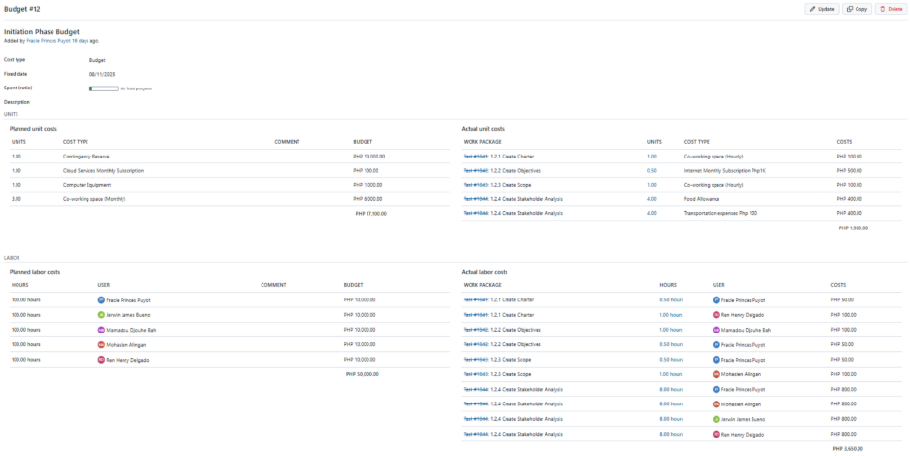

Planning Phase:

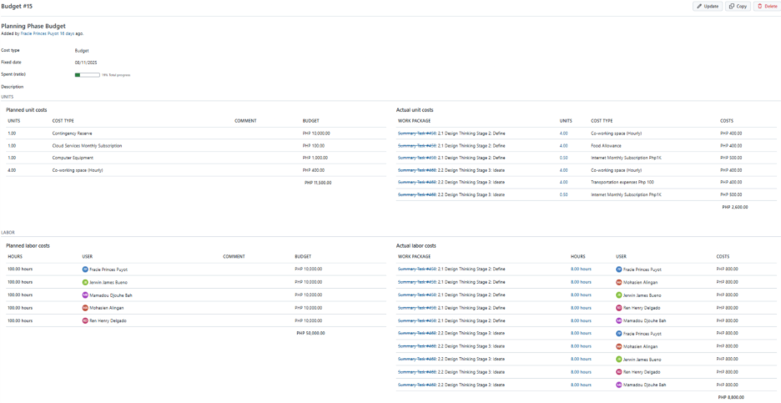

Executing Phase: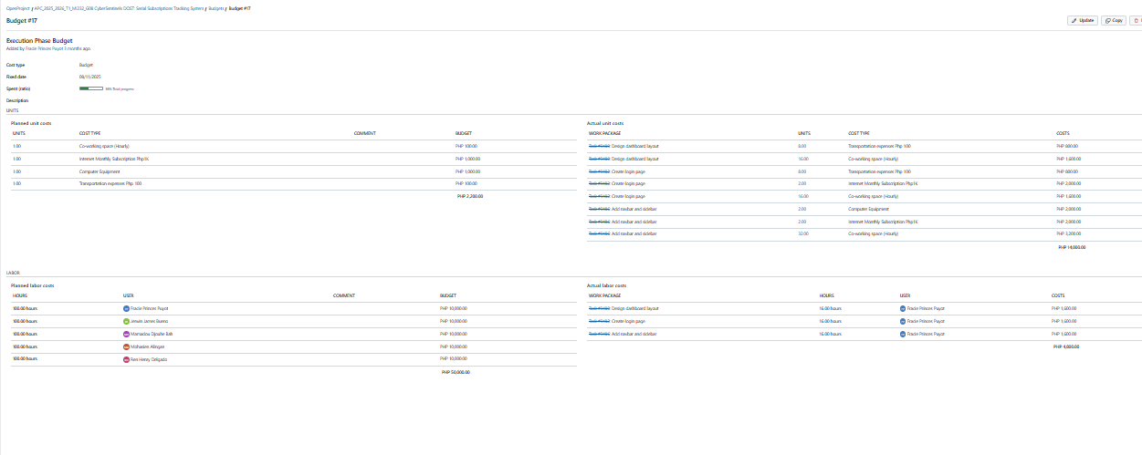

#### Roadmap

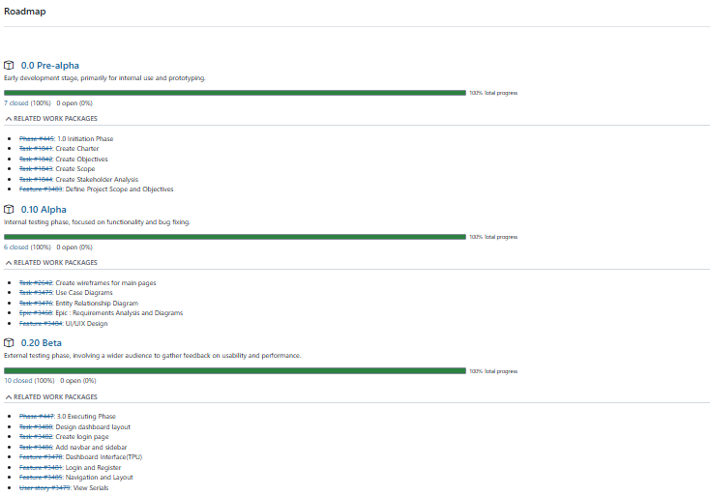

#### Work Packages

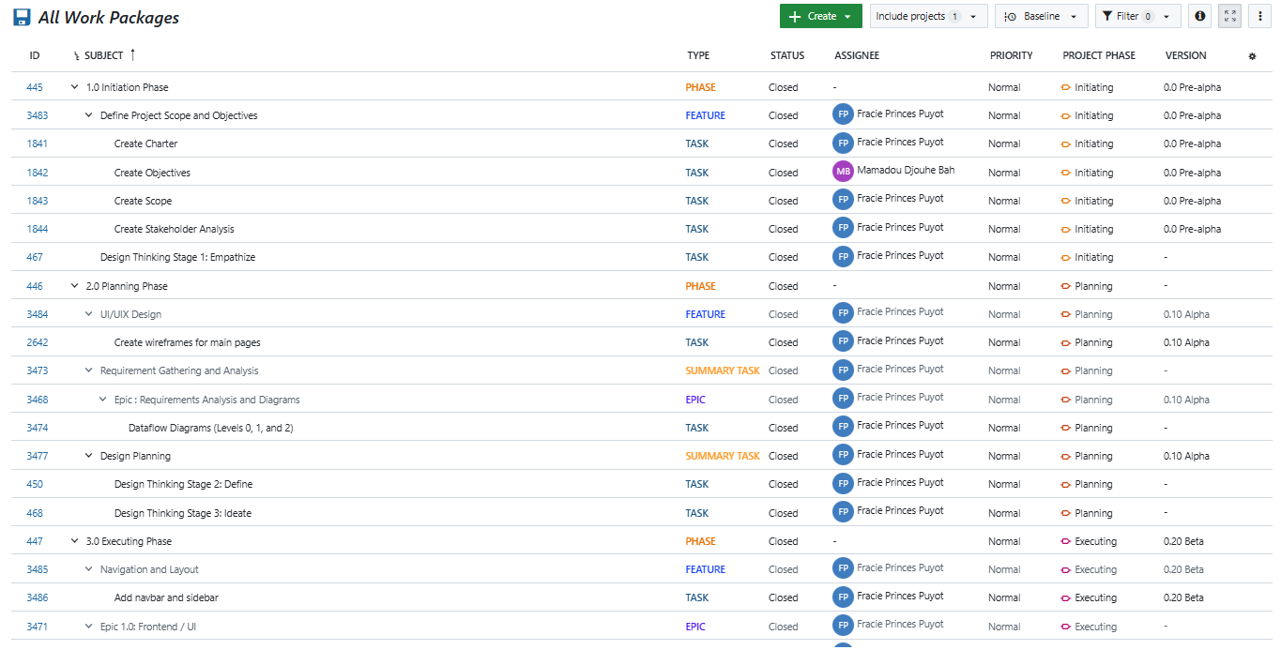

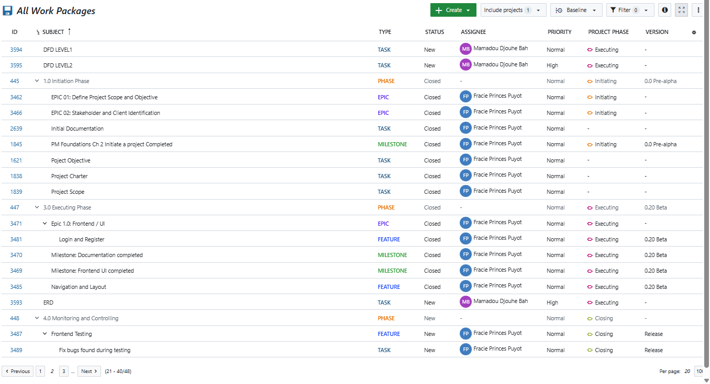

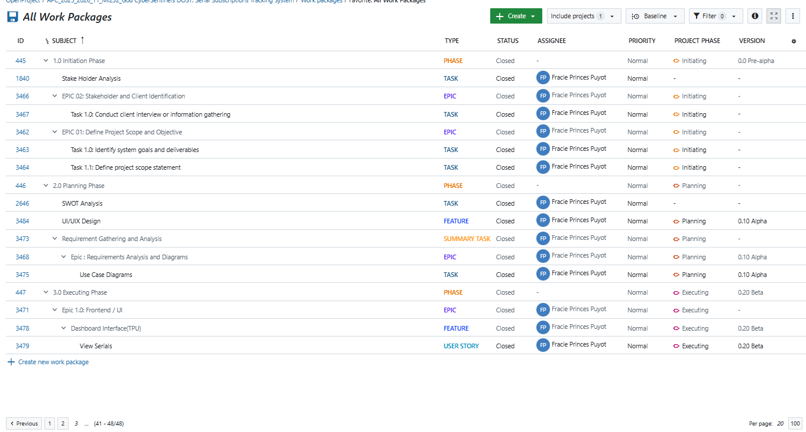

#### Backlogs

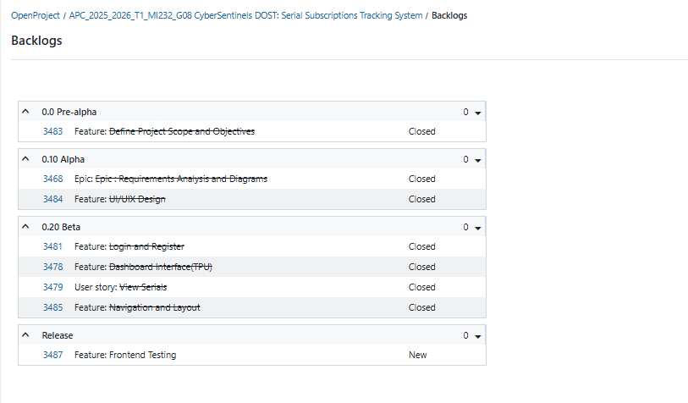

#### AY 2025-2026 T1 Sprint 01 Board

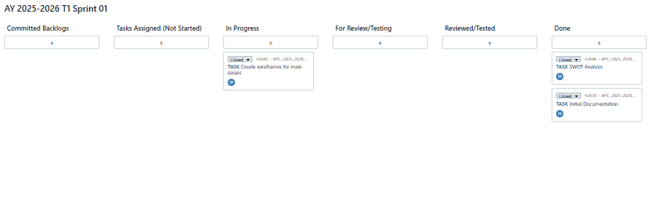

#### Gantt Chart

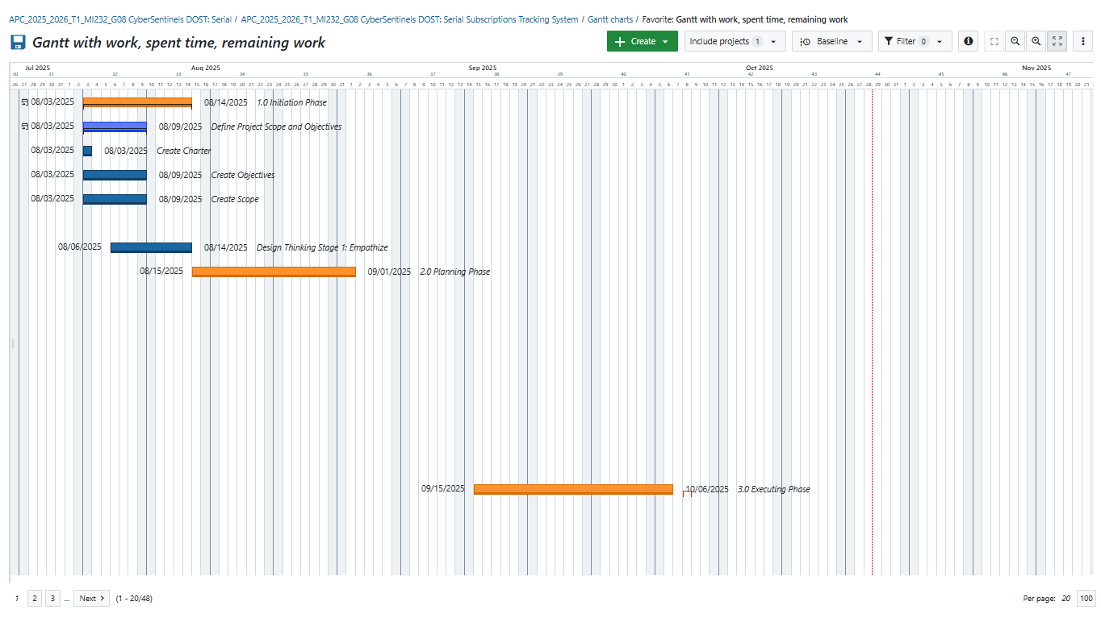

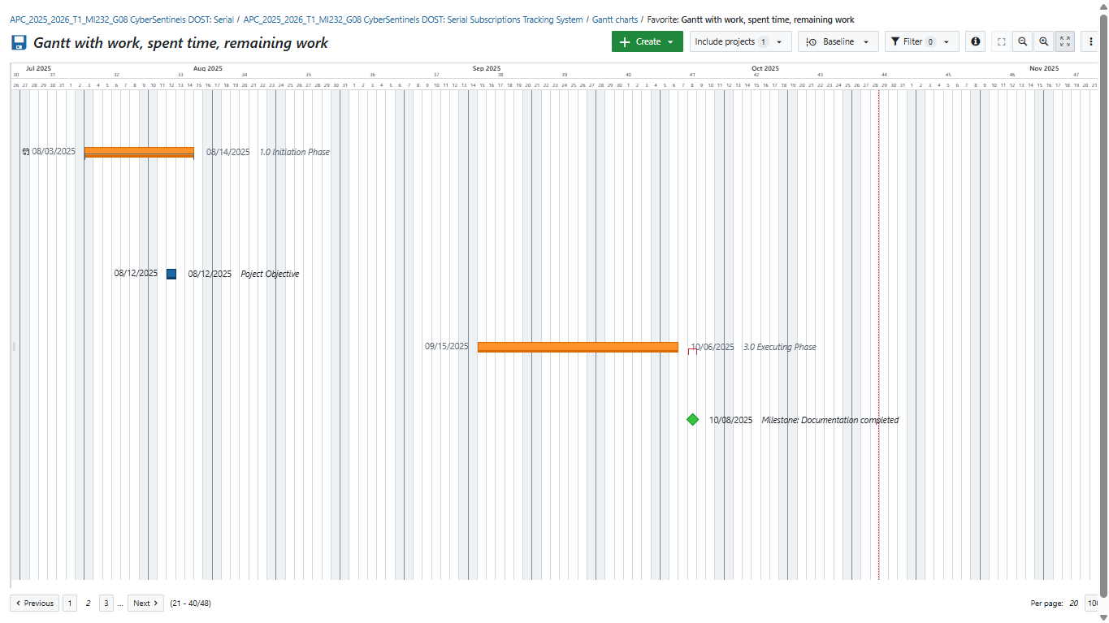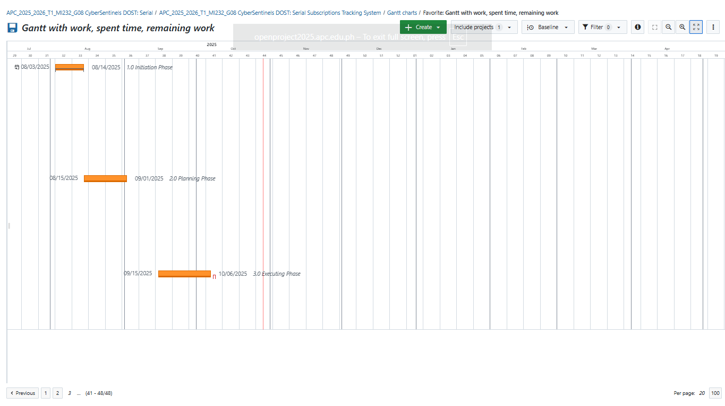

# Design Thinking Output

#### Stage 1 – Emphatize

The first stage of the design thinking process is Empathize, where we strive to understand the client’s perspective and gain deeper insight into their needs in order to identify and address the problem they are facing.

At DOST-STII, our team conducted an interview with our client, Ms. Nelly, to learn more about their situation and challenges. During the visit, we were also given a preview of their library. We observed that the space appeared messy and cluttered, filled with countless books and other materials. This observation highlighted how busy the staff are, as well as the large volume of resources they manage on a daily basis.

This experience allowed us to empathize with their struggles, recognizing that their current setup may be overwhelming and difficult to maintain. It gave us valuable insight into the need for a more organized and efficient system to help them manage their resources better.



*Figure 1 Client's Physical Location*

### **CLIENT AND CUSTOMER INTERVIEWS**

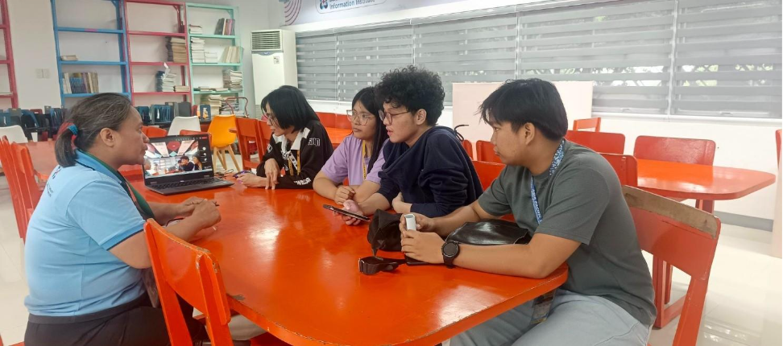

*Figure 2 Initial Customer Interview*

Despite the client’s busy schedule and limited availability, the group was able to arrange a meeting with them. The method agreed upon was a face-to-face meeting, where the group personally visited their workplace and interviewed them using the questions that had been prepared in advance.

#### The following are the questions that the group has made for the client and their answer:

1. Why does the TPU manually monitor serial publications?

* The TPU manually monitors serial publications because a dedicated automated system hasn't been implemented yet. This manual process is a result of the department not having foreseen the need for a more efficient, automated solution from the outset. As a result, staff members must painstakingly track each publication by hand, which is not only time-consuming but also prone to human error.

2. Why is it difficult to get timely and accurate financial and delivery reports?

* The difficulty in producing timely and accurate reports stems directly from the manual nature of the process. Timeliness is a challenge because a single person must check and record delivery details such as the number of pages and delivery dates for multiple titles from various suppliers. This can involve checking dozens of individual titles, a process that becomes extremely slow. Accuracy is also compromised because manual data entry and tracking are susceptible to human error, especially under tight deadlines or when the workload is high. An automated system would handle these tasks efficiently, drastically reducing both delays and mistakes.

3. Why is there no dedicated system that automatically tracks this information?

* A dedicated automated system wasn't put in place initially because the need for one wasn't fully recognized. When the current manual process was established, it was assumed that it would be sufficient and manageable. It was only after the process was underway that the problems of delays and inaccuracies became apparent, revealing the clear need for a more robust, automated solution that could handle the workload and improve efficiency.

4. Why does the current system lack these automated features?

* The current system lacks automated features for the same reason a new one wasn't built: the necessity for them wasn't anticipated. The department started with a manual process and didn't initially see the value in investing in an automated system. The need for these features became clear only after experiencing the limitations and inefficiencies of the manual process, such as the time-consuming nature of tracking and the frequent human errors.

5. Why is real-time communication between the TPU department and suppliers so crucial?

* Real-time communication with suppliers is critical for ensuring timely deliveries and having proof of follow-up for management. For both local and foreign suppliers, continuous communication is essential to prevent delays. Following up is especially important for foreign deliveries, which can take several months, as it provides a paper trail to show management that the department has done its part. Similarly, for local deliveries with a short turnaround time, constant communication prevents suppliers from forgetting or assuming a delivery was completed. In both cases, a system that automatically logs this communication would serve as undeniable evidence of the department's efforts, making the process more efficient and reliable.

**Open-Ended Questions 🗣️**

Q: Could you walk me through your typical workday and the steps you take to monitor serial issues?

* My workday in serial monitoring begins after the acquisitions team and Bids and Awards Committee (BAC) have completed their extensive process of selecting titles and suppliers. Once a supplier has been paid, my role shifts to tracking. I monitor each title to ensure the first issue is delivered promptly. Since different titles have varying delivery frequencies, some weekly, others monthly, I must keep a close eye on each one. This manual follow-up is a critical part of my day, and it takes precedence over other duties, like cataloging and encoding books and theses, which I also handle.

Q: What’s the most frustrating part of tracking undelivered items and following up with suppliers?

* The most frustrating part of my job is the feeling that a lot of my hard work goes to waste. Despite my constant follow-ups, some issues never get delivered by the end of the subscription period. All the time and effort I put into tracking and communicating with suppliers feel useless when the expected materials don't arrive. This puts me in a difficult position, as I’m then held accountable by management for the undelivered issues and the wasted budget, even though I did my best to monitor the process.

Q: How does the manual process for tracking subscriptions impact your daily work?

* The manual tracking process consumes a huge amount of my time, making it difficult to keep up with my other responsibilities. By the end of each semester, I am often behind on tasks like cataloging because the priority is always on monitoring serials. This is because there’s a financial risk involved. If I fail to monitor correctly, it not only wastes the department's budget but also creates accountability issues with accounting and management. More importantly, it impacts the library's users, who can't access the materials they need, which ultimately means that public funds don't deliver the expected benefits.

Q: Can you describe the steps you take when you need to follow up with a supplier?

* When I need to follow up with a supplier, my first step is to check my manual monitoring sheet to see what deliveries are expected that week. I then draft and send an email with a formal follow-up letter to the supplier. A major issue with this manual method is the uncertainty of whether the supplier actually receives or reads the email. This constant cycle of preparing and sending follow-up letters is time-consuming and often feels like a shot in the dark, with no guarantee of a response or action.

Q: How do communication gaps with suppliers or internal teams affect your work? Can you share an example?

* Communication gaps with suppliers and internal teams waste a significant amount of time and resources. Instead of focusing on my other essential tasks, I find myself stuck in a cycle of preparing and sending multiple follow-up letters. For example, in a single month, I might have to send five or six different letters to various suppliers due to their unique delivery schedules. This constant back-and-forth not only delays the delivery of materials but also prevents me from being productive in other areas of my work.

Q: What would an ideal “perfect” day look like for you in managing serial subscriptions?

* In an ideal world, my perfect day would be one where I am not bogged down by manual tracking and follow-ups. A system would handle the tedious work for me. I would simply input the title and delivery frequency, and the system would take over, automatically sending reminders to suppliers. This would also eliminate the need for me to manually gather proof of communication for management, as the system would generate and store those records. My role would become more strategic and efficient, freeing me up to focus on other tasks that require my direct attention.

Q: Are there recurring issues with specific titles or suppliers that the current system doesn’t handle well?

* Since we don’t have an automated acquisition system, every step is prone to human error. With so many different titles and volumes to track, it's easy to overlook a detail or make a mistake. For instance, I might miss a specific volume that was supposed to be delivered. An automated system would be able to handle these details with far greater accuracy. It could automatically record the receipt, inspection, and cataloging of each item, ensuring that nothing is missed and the records are always correct.

Q: If you could magically add one feature to a new system, what would it be and why?

* If I could add one magical feature to a new system, it would be a combination of an automated notification system and a chatbot. This feature would automatically send timely reminders to suppliers, eliminating the need for me to manually draft and send follow-up letters. The chatbot would also create a secure and easily accessible log of all communication, which would serve as irrefutable proof of my follow-up efforts. This single feature would save countless hours and provide me with the necessary documentation to show management that I have done my part.

### 

#### ACTUAL PERSONAS

 

**THEORETICAL PERSONAS**

**PERSONA 1: ALICE** (TPU – Senior Technician)

* Oversees encoding of serial numbers
* Supervises junior TPU staff
* Reports missing or duplicate serials to management

**PERSONA 2: DEREK** (Inspection Team)

* Oversees encoding of serial numbers
* Supervises junior TPU staff
* Reports missing or duplicate serials to management

**PERSONA 3: CODY** (TPU – Junior Staff)

* Encodes and scans items into the system
* Handles daily processing of serials
* Reports encoding issues to seniors

**PERSONA 4: JAMIE** (IT Team)

* Supports the tracking system and fixes errors
* Updates software and handles user issues
* Coordinates with departments when system glitches occur

**PERSONA 5: ADELINE** (GSPS – Coordinator)

* Tracks priority items and delivery status
* Monitors movement of serialized items
* Generates reports for audits and priority dispatch

### **EMPATHY MAP**

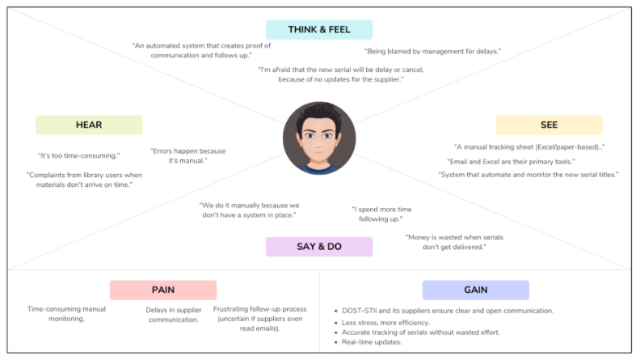*Figure 8 Empathy Map*

**SAY & DO:**

* “We do it manually because we don’t have a system in place.”
* “Spend more time following up."
* “Money is wasted when serials don’t get delivered.”

**THINK & FEEL:**

* “Automated system that proof of communication and follows up.”
* “I’m afraid that the new serial will be delay or cancel, because of no updates for the supplier.”
* “I’m afraid that the new serial will be delay or cancel, because of no updates for the supplier.”

**HEAR:**

* “Errors happen because it’s manual.”
* “It’s too time-consuming.”
* “We need proof for management, or they won’t believe we followed up.”

**SEE:**

* “A manual tracking sheet (Excel/paper-based).”
* “Email and Excel are their primary tools.”
* “System that automate and monitor the new serial titles.”

### **PAIN-GAIN ANALYSIS**

### **PAIN**

#### **What are the customers’ frustrations?**

#### Manual monitoring is time-consuming.

1. Delays in communication.
2. Repetitive follow-ups (5-6 monthly).
3. Errors occur due to manual work, resulting in delayed deliveries or overlooked details.
4. Other tasks (cataloging, processing, encoding) are delayed because follow-ups take precedence.
5. Responsibility is compromised; missed deliveries reflect negatively on TPU.
6. End-users like taxpayers lose trust when issues don’t arrive despite approved budgets.
7. What prevents the customers from being satisfied?
8. No automated system; reliance on spreadsheets and emails.
9. No real-time racking of deliveries.
10. No guaranteed supplier response.
11. Overlapping workflows cause bottlenecks.

#### **GAIN**

1. What are the customers’ expectations?
   1. Clear communication
   2. Faster, more efficient process with fewer repitive tasks.
   3. Accuracy through automated logs and reports.
   4. Transparency in tracking deliveries and finances.
   5. Automatic supplier notifications and reminders.
   6. Automatic supplier notifications and reminders.
   7. Integrated workflow connecting TPU, GSPS, suppliers, and libraries.
   8. Balanced workload, less stress, and prompt delivery to end-users.
2. What satisfies the customers?
   1. Balanced workload, less stress, and prompt delivery to end-users.
   2. Automated follow-ups with records stored as evidence.
   3. Safe, reliable system that prevents wasted time, effort, and budget.
   4. End-users such as taxpayers get publications on time, ensuring value for money.

ANALYSIS:

* To have an automated system that is simple, accessible, and user-friendly.
* To have a feature that provides real-time updates on deliveries, payments, and financial reports.
* To provide staffs a way to send follow-ups and notifications with proper records as proof.
* To provide internal stakeholders a way to track subscriptions safely and accurately, minimizing human errors.
* To have a transparent and integrated workflow connecting TPU, GSPS, suppliers, and inspection.
* To have a system that reduces workload, prevent delays, and ensures end-users receives publications on time.

#### Stage 2 – Define

In this stage, we listed all the problems we gathered from our interviews with our client.

Thanks to stage 1 findings we were able to group these issues into clusters.

**Manual & Time-Consuming Process**

* Monitoring is done manually using spreadsheets and emails.
* Takes up too much time → delays other duties like cataloging.
* Repetitive follow-ups (5–6 monthly).

**Communication Gaps**

* No guaranteed supplier response.
* Difficult to prove follow-ups to management.
* No real-time communication between TPU and suppliers.

**Errors & Inefficiencies**

* High chance of human error in monitoring.
* Missing or delayed deliveries.
* Accountability issues (budget wasted, staff blamed).

**Lack of Integrated System**

* No automated notifications or reminders.
* No centralized tracking of deliveries, payments, and reports.

**How might we**

* reduce the manual workload of monitoring and following up with suppliers?
* design a system that saves staff time while ensuring accuracy?
* create a reliable channel for real-time communication between TPU and suppliers?
* automatically document supplier interactions as proof for management?
* minimize human errors in tracking deliveries and reports?
* ensure no serial issue gets overlooked?
* build an integrated platform that connects TPU, GSPS, suppliers, and libraries?
* automated reminders, updates, and financial tracking in one place?
* reduce staff stress and workload while improving trust in the system?

**Problem Statement:**

TPU staff need a simple, automated, and integrated system for tracking serial publications and communicating with suppliers because the current manual process is time-consuming, error-prone, and causes delays that affect staff efficiency.

#### Stage 3 – Ideate

**BRAINSTORMING SESSION**

**Problem Statement:** The current manual system at the DOST-STII Library for managing serial publication subscriptions creates operational challenges. These challenges include inconsistent and delayed monitoring, ineffective communication with suppliers, time-consuming manual documentation, and a lack of financial visibility for serial items.

**How Might We Questions to Guide Brainstorming:**

1. How might we automate the tracking of serial issues to reduce delays and manual work for the TPU?
2. How might we improve communication between the TPU and suppliers to get timely updates on delivery issues?
3. How might we make financial data on serials more visible and easier to report?
4. How might we streamline the process of preparing quarterly reports on delivered and undelivered issues?
5. How might we provide automated notifications to relevant stakeholders about delivery statuses?   
     
   **Brainstormed Solutions (Potential Features):**
6. **Real-time tracking dashboard:** A centralized dashboard that provides a real-time view of all subscribed serials, their delivery status, and expected delivery dates.
7. **Automated notification system:** The system will send reminders and alerts to the TPU about expected deliveries and notify suppliers of any undelivered issues with detailed information.
8. **Supplier communication portal:** A feature that allows suppliers to report publishing or shipment issues and update new expected delivery dates directly within the system.
9. **Reporting module:** A module that can automatically generate reports on delivery performance, undelivered items, and cost summaries. This could include a quarterly report on titles, quantities of delivered/undelivered issues, and total costs.
10. **Role-based access:** Tailored interfaces and permissions for different stakeholders, such as the TPU, suppliers, the Inspection Team, and others.
11. **Financial visibility tools:** The system can track costs and provide automated cost deductions for confirmed deliveries to enhance financial visibility.

**Search and filter functionality:** The ability to search for specific serial titles, suppliers, or issues to quickly find information.

**CRAZY 8'**

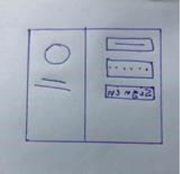 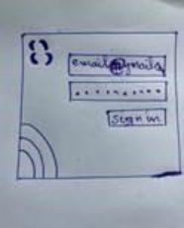 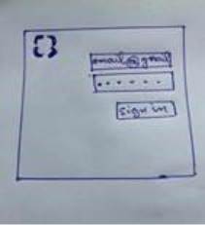 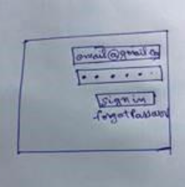

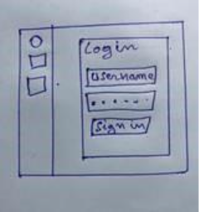 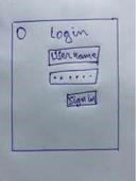 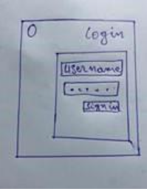 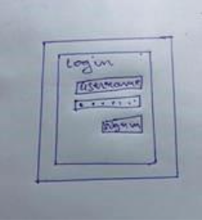

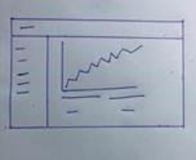 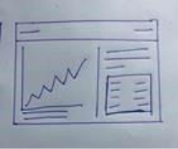 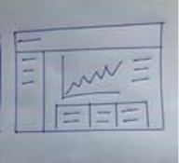 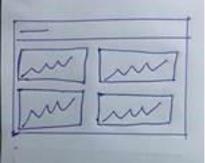

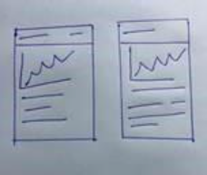 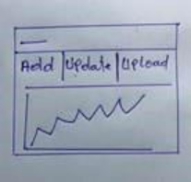 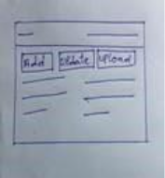 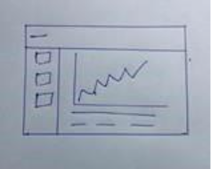

#### 

**Post it voting**

|  |  |  |
| --- | --- | --- |
| Admin dashboard for managing accounts and roles. The system also includes role-based dashboards for different users, Technical Processing Unit (TPU), GSPS, Inspection Team, and Suppliers. An inventory tab is also mentioned, which would be useful for tracking items. | Real-time delivery status tracking. It will also include automated notifications to alert users about expected, delayed, or undelivered issues. The system will also have a multi-level login system. | Reporting module. It can generate Excel-based reports that show delivery performance, undelivered items, and cost summaries. The goal is to reduce report generation time by 50% |
| The system will have automated cost deduction for confirmed deliveries. One of the objectives is to enhance the financial visibility of serial items by 75%. | TPU and suppliers. It alerts the TPU about expected delivery dates and notifies suppliers of their delivery. The project's goal is to improve communication to reduce response time by 87.5%. |  |
| Financial Visibility: The system aims to enhance financial visibility of serial items by 75%. It allows for automated cost deduction for confirmed deliveries and helps in preparing reports that review the total cost of undelivered serials. | Real-time Delivery Status Tracking: This feature allows for the real-time tracking of delivery statuses. The main objective is to reduce delays in identifying and tracking undelivered serials by 50%. |  |
| Reporting Module: The system can generate reports in Excel format. These reports display delivery performance, undelivered items, and cost summarizations. The objective is to reduce report generation time by 50% through automation. | Automated Notifications: The system will send reminders and alerts to relevant stakeholders about expected, delayed, or undelivered issues. It also alerts the TPU about expected delivery dates and notifies suppliers of their delivery. |  |

**DESIRABLE, VIABLE, FEASIBLE**

|  |  |  |
| --- | --- | --- |
| Title | Admin dashboard for managing accounts and roles. The system also includes role-based dashboards for different users, Technical Processing Unit (TPU), GSPS, Inspection Team, and Suppliers. An inventory tab is also mentioned, which would be useful for tracking items. | Real-time delivery status tracking. It will also include automated notifications to alert users about expected, delayed, or undelivered issues. The system will also have a multi-level login system. |
| Desirability | Checkmark with solid fillCheckmark with solid fillCheckmark with solid fillCheckmark with solid fillCheckmark with solid fill | Checkmark with solid fillCheckmark with solid fillCheckmark with solid fillCheckmark with solid fillCheckmark with solid fill |
| Viability | Checkmark with solid fillCheckmark with solid fillCheckmark with solid fillCheckmark with solid fillCheckmark with solid fill | Checkmark with solid fillCheckmark with solid fillCheckmark with solid fillCheckmark with solid fillCheckmark with solid fill |
| Feasibility | Checkmark with solid fillCheckmark with solid fillCheckmark with solid fillCheckmark with solid fillCheckmark with solid fill | Checkmark with solid fillCheckmark with solid fillCheckmark with solid fillCheckmark with solid fillCheckmark with solid fill |

|  |  |  |  |
| --- | --- | --- | --- |
| Automated Notifications: The system will send reminders and alerts to relevant stakeholders about expected, delayed, or undelivered issues. It also alerts the TPU about expected delivery dates and notifies suppliers of their delivery. | Reporting module. It can generate Excel-based reports that show delivery performance, undelivered items, and cost summaries. The goal is to reduce report generation time by 50% | The system will have automated cost deduction for confirmed deliveries. One of the objectives is to enhance the financial visibility of serial items by 75%. | TPU and suppliers. It alerts the TPU about expected delivery dates and notifies suppliers of their delivery. The project's goal is to improve communication to reduce response time by 87.5%. |
| Checkmark with solid fillCheckmark with solid fillCheckmark with solid fillCheckmark with solid fillCheckmark with solid fill | Checkmark with solid fillCheckmark with solid fillCheckmark with solid fillCheckmark with solid fillCheckmark with solid fill | Checkmark with solid fillCheckmark with solid fillCheckmark with solid fillCheckmark with solid fillCheckmark with solid fill | Checkmark with solid fillCheckmark with solid fillCheckmark with solid fillCheckmark with solid fillCheckmark with solid fill |
| Checkmark with solid fillCheckmark with solid fillCheckmark with solid fillCheckmark with solid fillCheckmark with solid fill | Checkmark with solid fillCheckmark with solid fillCheckmark with solid fillCheckmark with solid fillCheckmark with solid fill | Checkmark with solid fillCheckmark with solid fillCheckmark with solid fillCheckmark with solid fillCheckmark with solid fill | Checkmark with solid fillCheckmark with solid fillCheckmark with solid fillCheckmark with solid fillCheckmark with solid fill |
| Checkmark with solid fillCheckmark with solid fillCheckmark with solid fillCheckmark with solid fillCheckmark with solid fill | Checkmark with solid fillCheckmark with solid fillCheckmark with solid fillCheckmark with solid fillCheckmark with solid fill | Close with solid fillClose with solid fillClose with solid fillClose with solid fillClose with solid fill | Checkmark with solid fillCheckmark with solid fillCheckmark with solid fillCheckmark with solid fillCheckmark with solid fill |

|  |  |  |
| --- | --- | --- |
| Real-time Delivery Status Tracking: This feature allows for the real-time tracking of delivery statuses. The main objective is to reduce delays in identifying and tracking undelivered serials by 50%. | Reporting Module: The system can generate reports in Excel format. These reports display delivery performance, undelivered items, and cost summarizations. The objective is to reduce report generation time by 50% through automation. | Financial Visibility The system aims to enhance financial visibility of serial items by 75%. It allows for automated cost deduction for confirmed deliveries and helps in preparing reports that review the total cost of undelivered serials. |
| Checkmark with solid fillCheckmark with solid fillCheckmark with solid fillCheckmark with solid fillCheckmark with solid fill | Checkmark with solid fillCheckmark with solid fillCheckmark with solid fillCheckmark with solid fillCheckmark with solid fill |  |
|  |  |  |
|  |  |  |

#### Stage 4 – Prototype

#### **MOCKUP DESIGN**

#### Log In

#### 

#### TPU

#### SUPPLIER

#### GSPS

#### ADMIN/IT

#### INSPECTION TEAM

#### Stage 5 – Test

#### Client Feedback

1. **Remove public role-selection buttons**. Only Admin assigns roles.
2. **Supplier registration process:** Admin generates the account and provides a temporary password, which suppliers must change upon first login.

1. **Current Left-Side Tabs (Navigation):** Not standard; suggested to switch to

**AdminLTE-style** navbar or sidebar.

1. Suggested UI improvement: Users are more familiar with standard dashboard layouts for better UX.
2. Dashboard should display:

* Total expected vs. delivered issues per title
* Total cost, used cost, and remaining cost
* Compliance status per supplier

# Dataflow Diagrams

#### Level 0

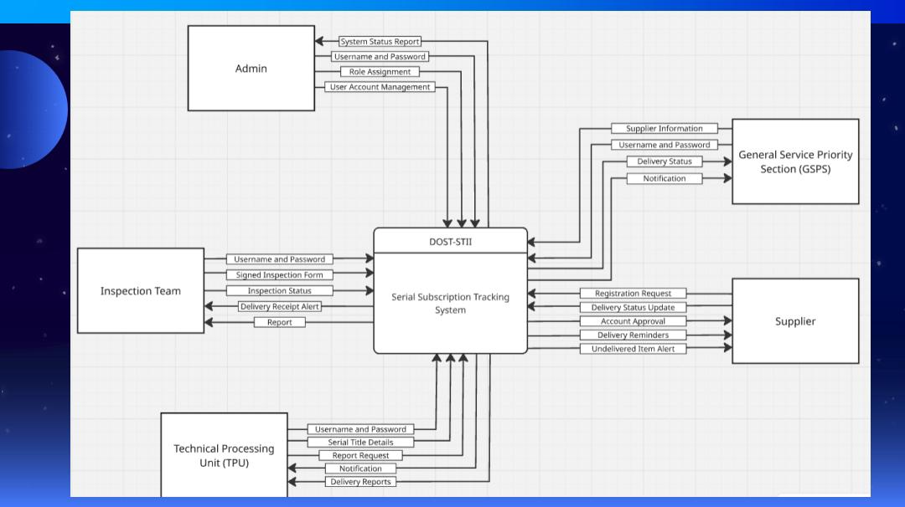

#### Level 1 Diagram

#### Level 2 Diagrams Send Message

Inspect Serial

Manage Serial

Manage Profile

# Use Case Documentation

#### Use Case Diagram

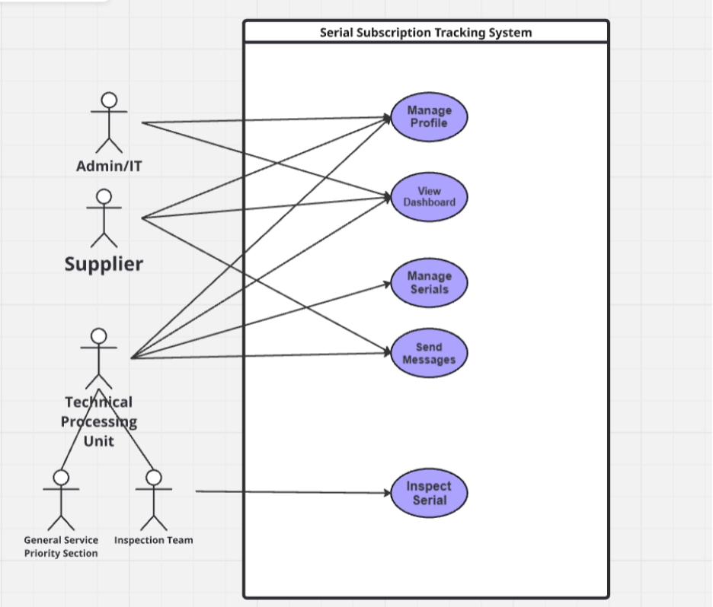

#### Fully Dressed Use Cases

|  |  |
| --- | --- |
| Use Case Name | *Manage Profile* |
| Use Case ID: | *UC-01* |
| Author | *Cyber Sentinels* |
| Purpose | *Allows users to manage their personal and organizational information to ensure that all system activities are traceable to verified users.*  *Admin/IT can also manage user accounts and assign roles.* |
| Requirement Traceability | *BR-01, BR-02, BR-11* |
| Priority | *High* |
| Preconditions | * *The user must be logged into the system* * *User must have a valid system account* * *Admin must have verified the account and assigned a role* |
| Postconditions | * *User profile data is saved and logged in the system* |
| Actors | *All Users* |
| Flow of Actions | **Main Flow: (IT/ADMIN)**   1. Admin logs into system. 2. Navigates to User Management. 3. Creates new user account. 4. Assigns appropriate role (Supplier, TPU, GSPS, Inspection). 5. Verifies account and saves changes. 6. System sends notifications to user.   **Main Flow: Other Actors**   1. User navigates to login page. 2. Enters valid credentials. 3. Clicks Login. System authenticates credentials. 4. User is redirected to their dashboard.   **Alternate Flow:**  Invalid Username or Password   1. User navigates to login page. 2. Enter Invalid credentials 3. System displays “Login failed.”   Unregistered User   1. Input username or password 2. The user is prompted with a message “User is not registered” 3. The page stays in the login page |

|  |  |
| --- | --- |
| Use Case Name | *View Dashboard* |
| Use Case ID: | *UC-02* |
| Author | *Cyber Sentinel* |
| Purpose | *Provides a personalized dashboard that displays role-based summaries and system reports relevant to each actor’s functions.* |
| Requirement Traceability | BR-03, BR-12 |
| Priority | *High* |
| Preconditions | * *User is logged in* |
| Postconditions | * *Dashboard displays data and metrics relevant to the user’s role* |
| Actors | *All Users* |
| Flow of Actions | **Main Flow:**   1. User logs in. 2. System identifies role. 3. Loads corresponding dashboard view  * TPU:Serial statuses, pending acknowledgments. * Supplier: Delivery and inspection progress. * GSPS: Deliveries awaiting inspection. * Inspection Team: Items for inspection  1. User can view or export reports   **Alternate Flow:**   1. System temporarily unavailable 2. Displays “Dashboard unavailable, please try again later.” |

|  |  |
| --- | --- |
| Use Case Name | *Manage Serial* |
| Use Case ID: | *UC-03* |
| Author | *Cyber Sentinels* |
| Purpose | *Facilitates encoding, receiving, updating, and acknowledging of serial publications across the system.* |
| Requirement Traceability | *BR-04, BR-06, BR-08, BR-11* |
| Priority | *High* |
| Preconditions | * *User must be logged in as TPU and GSPS,* |
| Postconditions | * *Serial data is updated and stored.* * *Delivery and inspection status changes trigger notifications* * *All updates are recorded in the audit log* |
| Actors | *TPU, GSPS,* |
| Flow of Actions | **Main Flow (TPU):**   1. TPU logs in and selects “Manage Serial.” 2. TPU encodes awarded serials (title, supplier, issue count, expected delivery). 3. TPU updates serial information when inspection is completed. 4. TPU acknowledges receipt of inspected items   **Main Flow (GSPS):**   1. GSPS logs in and accesses “Manage Serial.” 2. GSPS confirms receipt of serials from Supplier and updates system status to “For Inspection”   **Alternate Flow:**   1. System encounters an error retrieving real-time data 2. Displays a message: “Please refresh or try again later.” |

|  |  |
| --- | --- |
| Use Case Name | Send Messages |
| Use Case ID: | *UC-04* |
| Author | *Cyber Sentinels* |
| Purpose | *Allows users to communicate and collaborate directly within the system for faster coordination and clarification.* |
| Requirement Traceability | BR-05, BR-09, BR-11 |
| Priority | *High* |
| Preconditions | * *Both sender and receiver must have active accounts.* |
| Postconditions | * *Message is delivered and stored for audit* |
| Actors | *Supplier, TPU, GSPS, Inspection Team* |
| Flow of Actions | **Main Flow**:   1. User opens “Send Messages.” 2. User selects a recipient and composes a message. 3. System delivers the message to the recipient’s inbox. 4. Recipient receives a notification about the new message. 5. Both sender and receiver can view the message history.   **Alternate Flows**:   1. Message delivery fails due to connection issues 2. System retries or queues the message. |

|  |  |
| --- | --- |
| Use Case Name | *Notifications* |
| Use Case ID: | *UC-05* |
| Author | *Cyber Sentinels* |
| Purpose | *Sends system-generated alerts to users when certain actions or events occur, ensuring real-time updates.* |
| Requirement Traceability | *BR-10, BR-11* |
| Priority | *High* |
| Preconditions | * User must be logged in or have a registered account. * Triggering event must exist (message, delivery, inspection, acknowledgment) |
| Postconditions | * Users stay updated with all relevant actions. * Notification logs are stored for system traceability |
| Actors | *System* |
| Flow of Actions | **Main Flow:**   1. *System detects an event* 2. *System generates a notification for affected users.* 3. *User receives and views notification in the dashboard.* 4. *Notification directs user to relevant module*   **Alternate Flow:**   1. *If user is offline, notification appears at next login.* |

|  |  |
| --- | --- |
| Use Case Name | *Inspect* |
| Use Case ID: | *UC-06* |
| Author | *Cyber Sentinels* |
| Purpose | *Enables the Inspection Team to review, verify, and document the quality and completeness of delivered serials.* |
| Requirement Traceability | *BR-07, BR-10, BR-11* |
| Priority | *High* |
| Preconditions | * *GSPS must have marked items as “For Inspection.”* |
| Postconditions | * *Inspection data and reports are recorded* * *Notification is sent to TPU and GSPS indicating inspection completion.* |
| Actors | *Inspection Team* |
| Flow of Actions | **Basic Flow**   1. Inspection Team logs in and opens “Inspect.” 2. System lists serials awaiting inspection. 3. Inspection Team reviews each serial for quality and completeness. 4. The inspection Team marks the result as Accepted or Not Accepted. 5. Inspection Team fills out the inspection report as proof. 6. System stores data and send notification to TPU and GSPS about the results   **Alternate Flow**   1. Missing report file 2. System prompts user to upload before saving |

#### Activity Diagrams with Swim-Lanes

#### Manage Serial (TPU)

#### Manage Serial (GSPS)

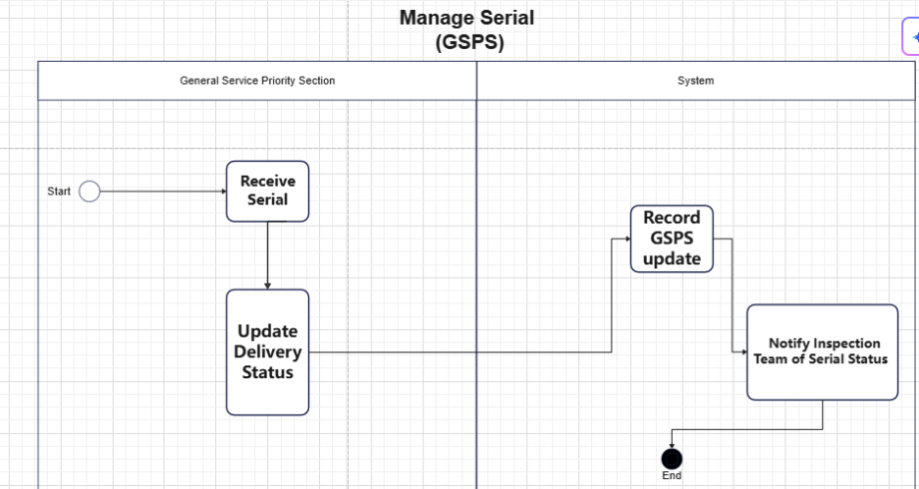View Dashboard

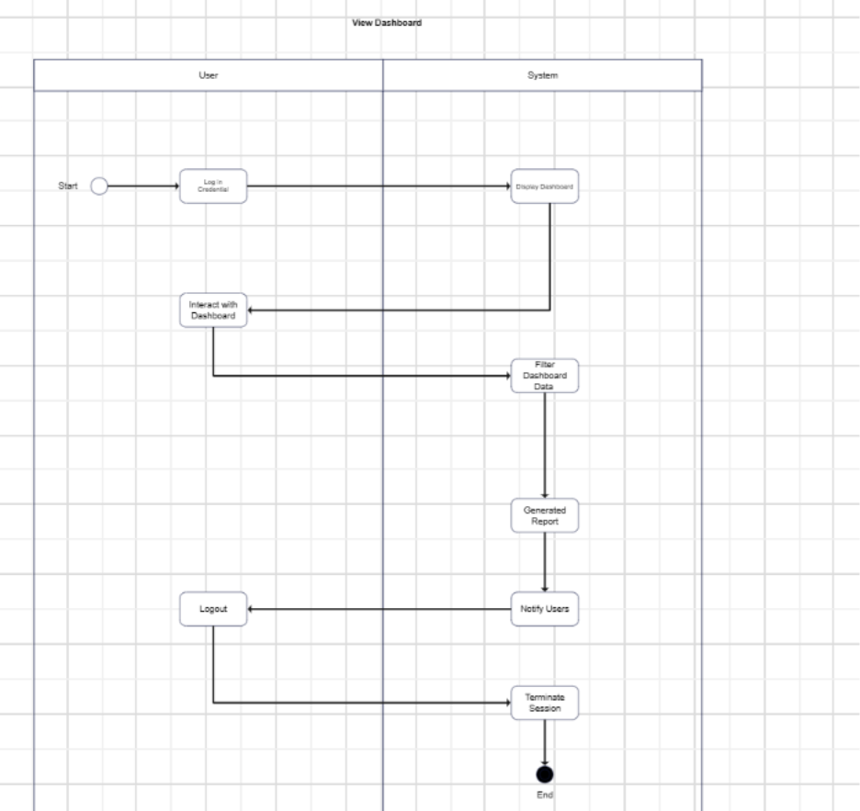

#### Manage Profile

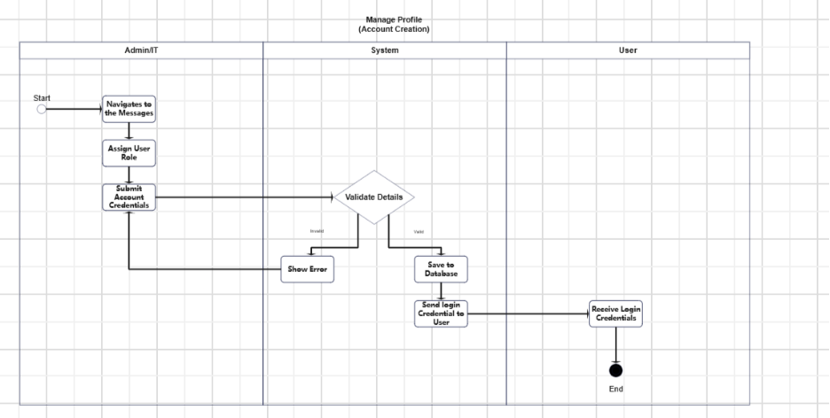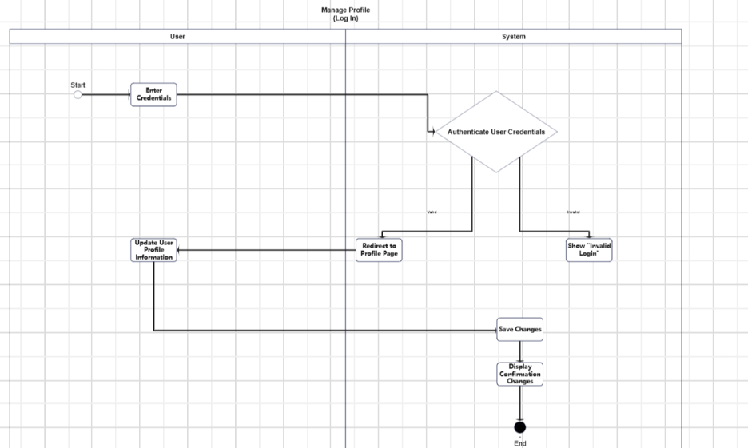

#### Send Messages

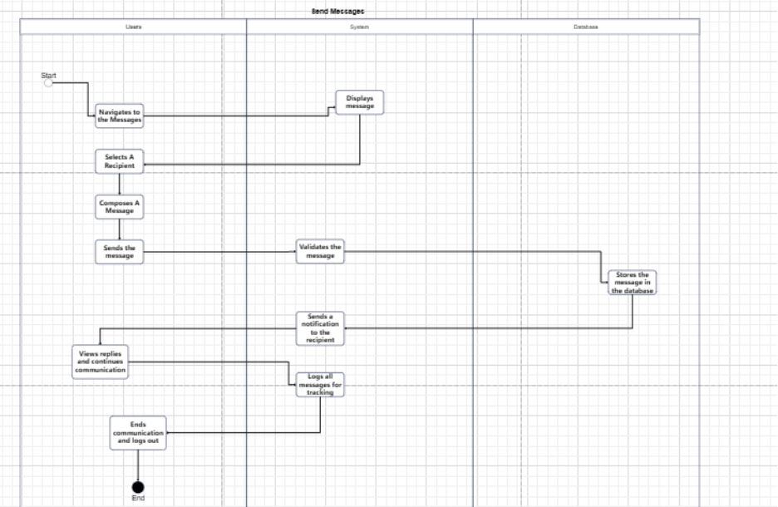

#### Inspect Serials

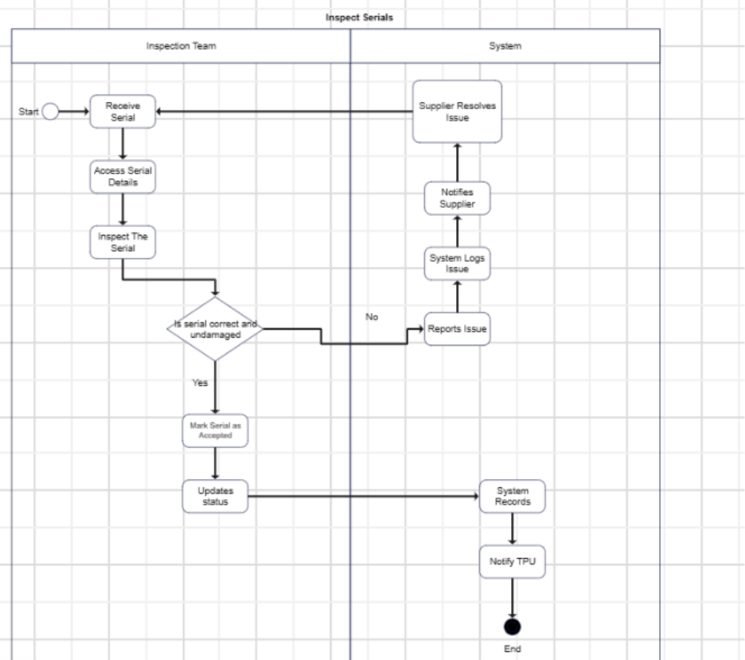

#### Entity Relationship Diagram

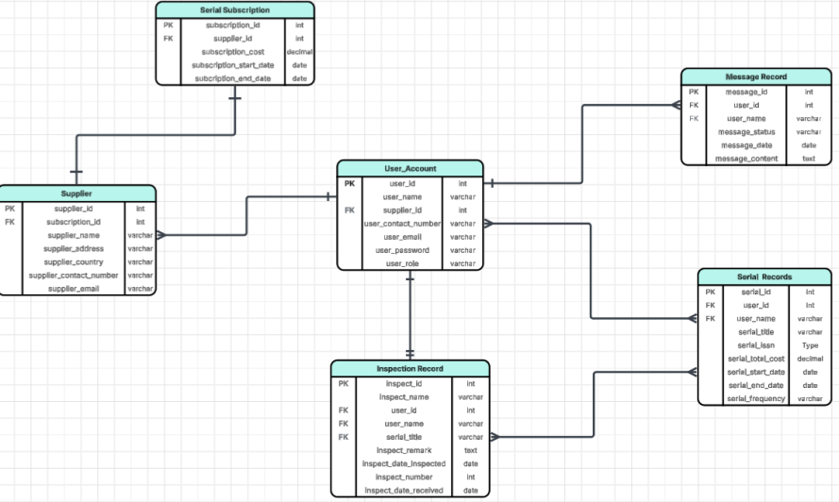

# Technology Stack

#### Frontend Framework

#### React

#### Backend Framework

* Laravel
* MongoDB

#### Frontend/Backend Communication

* Rest API and Websocket

Github APC-SoCIT project repository URL [Link](https://github.com/APC-SoCIT/APC_2025_2026_T1_MI232_G08-DOST-Serial-Subscriptions-Tracking-System)

Link Openproject Team Site URL [Link](https://openproject2025.apc.edu.ph/projects/apc-2025-2026-t1-mi232-g08-cybersentinels-dost-serial-subscriptions-tracking-system/)